**Updated March 2025**

# ESEA PMSA Process Guide for GAINS

## Initial Submission

1. To begin the Program Monitoring Self-Assessment (PMSA) in GAINS, hover over “Monitoring” in the left navigation bar and select “Monitoring Instruments.”

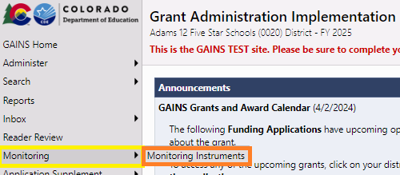

1. The next page allows the LEA to select the appropriate Monitoring tool. Make sure that the dropdowns include the current year (“2025” in the example) and “Active.” Select the “ESEA Program Monitoring Self-Assessment.”

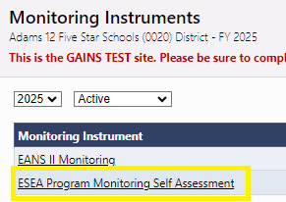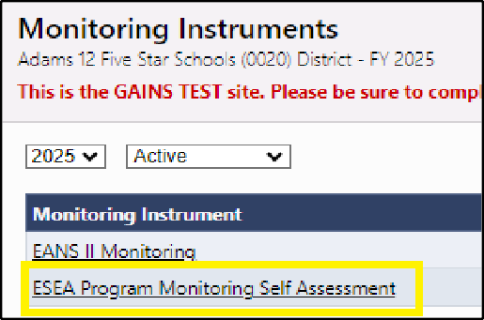

1. The Monitoring Self-Assessment will open on the Sections page. Before opening a page, be sure to change the Status to “Draft Started.”
2. All sections of the PMSA are now displayed under “ESEA Self-Assessment.” The LEA may begin to enter information into the self-assessment. **Please read through the Instructions first before proceeding to subsequent sections.**

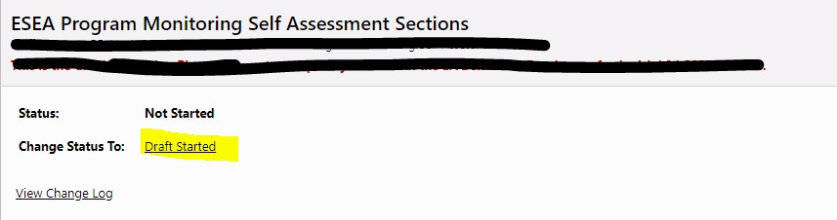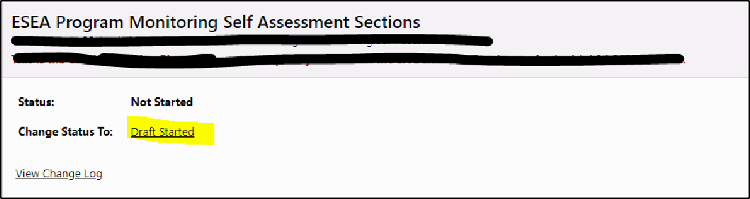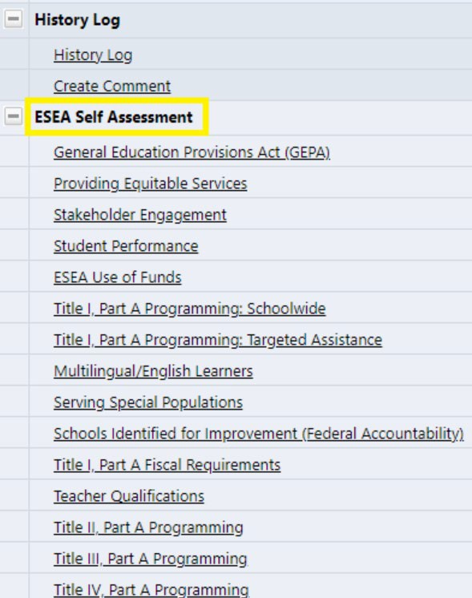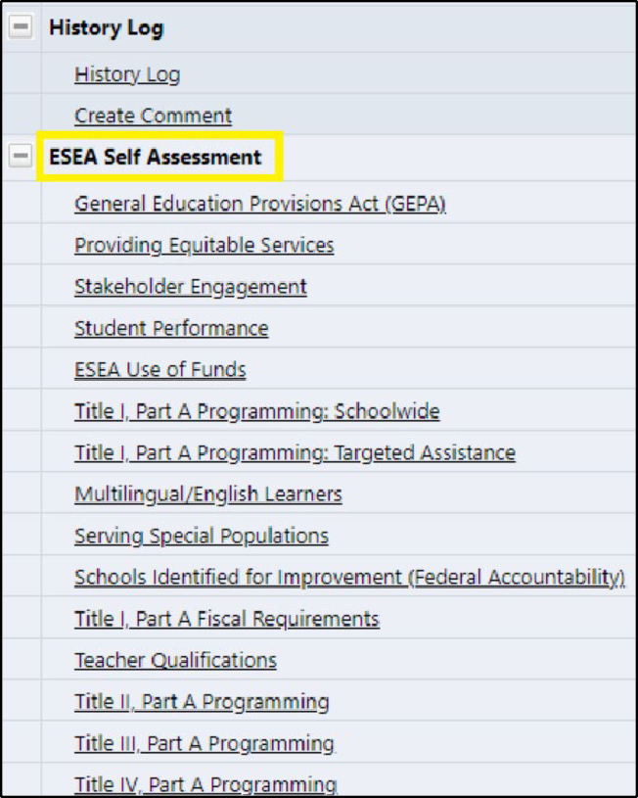

1. Each page within the PMSA will contain the same structure. The pages will have the following components for the LEA to complete. A screenshot of the “General Education Provisions Act (GEPA)” page has been provided as an example.
   * Program Requirements
     + Read all program requirement statements. Use the checkboxes to indicate which requirements are currently in compliance for the LEA. Please refer to the [Federal](https://www.cde.state.co.us/fedprograms/fedpgms_monitor_requirements) [Programs Monitoring Requirements](https://www.cde.state.co.us/fedprograms/fedpgms_monitor_requirements) document for further information.
   * LEA Self-Rating
     + Based on the review of the program requirements, make a selection that reflects the LEA’s overall implementation for the section being reviewed.
   * Narrative Summary
     + Provide a rationale for the self-rating, including the LEA’s process for ensuring that requirements are met. Additional Narrative Response Guidance is provided in Appendix A.
   * Checklist of Supports
     + Select what support(s) CDE can provide.
   * Document Upload
     + Submitting documentation is not required, however, the Program Monitoring Office team may request additional evidence during the review process; uploading evidence (documents and/or links) is highly encouraged
     + Please refer to the “Examples of Evidence” provided throughout the [Federal](https://www.cde.state.co.us/fedprograms/fedpgms_monitor_requirements) [Programs Monitoring Requirements](https://www.cde.state.co.us/fedprograms/fedpgms_monitor_requirements) document for additional information.

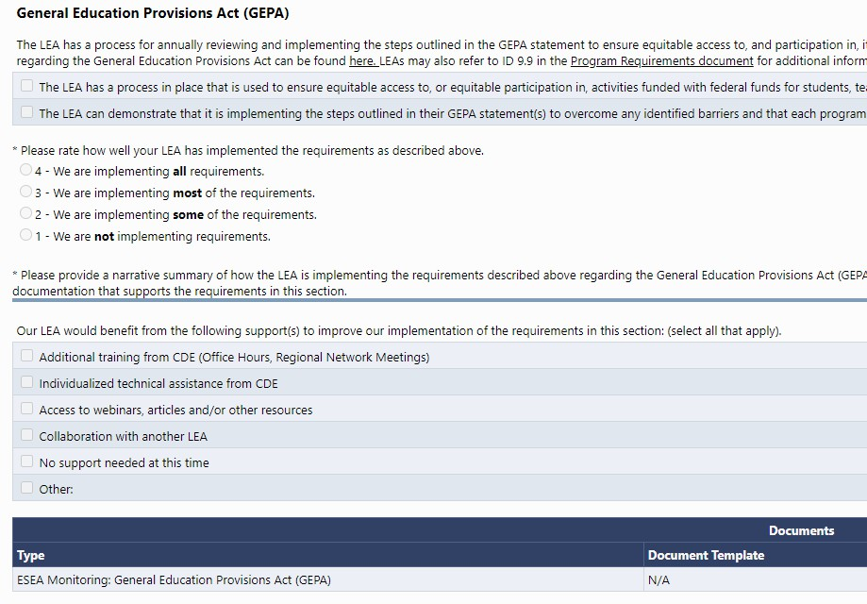

1. Proceed with completing all sections of the PMSA. ***Please keep in mind that all questions with an asterisk (*) require a response. Not providing a response will generate an error and prevent submission.***
2. Once all sections are complete, return to the “Sections” page and review and resolve any Validation messages.

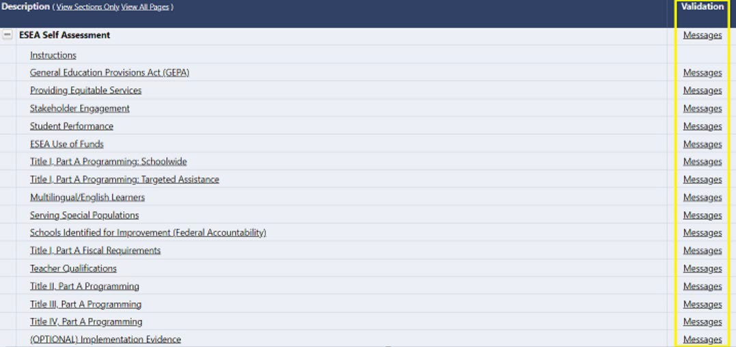

1. Change the Status to “Draft Completed” to begin the LEA approval process. In order to submit the PMSA to CDE for review, the Status will then need to be changed to “LEA Authorized Representative Approved.” ***Note: Hovering over the clickable status updates will display the role(s) and user(s) who can perform each function.***

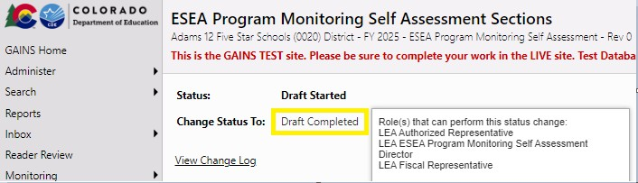

## Review and Results

1. Once submitted, the Program Monitoring Office team will complete a comprehensive review of the submitted self-assessment. ***Note: The initial rating provided may not be the LEA’s final rating. The LEA will have the opportunity to respond to requests for additional documentation before compliance ratings, as well as any recommendations and/or corrective actions, are determined.***
2. When the Program Monitoring Office team review is complete, the LEA will receive notification that the Status has been changed to “CDE Director Reviewed.”

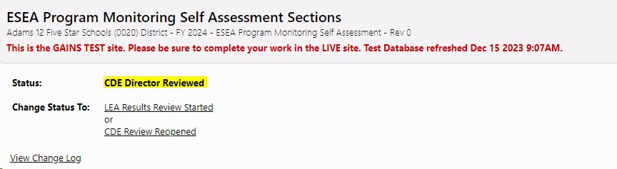

1. 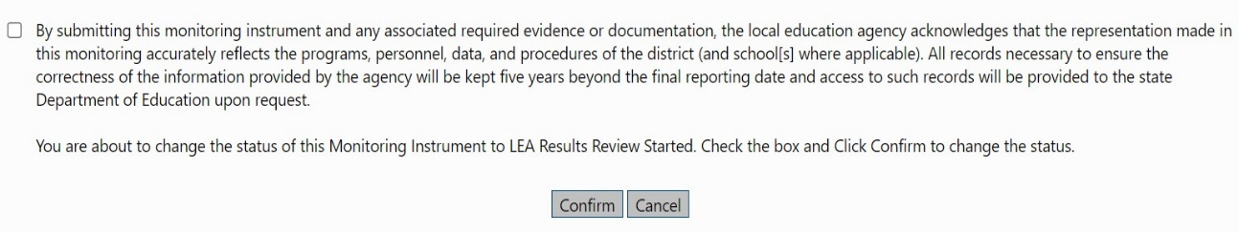To continue the monitoring process, change the Status to “LEA Results Review Started.” When the following message appears, check the box and click on Confirm to proceed.
2. 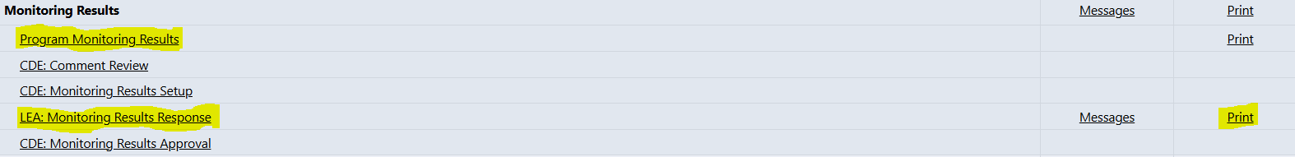The LEA will now be able to access the “Program Monitoring Results” overview and the “LEA: Monitoring Results Response” page for a summary of the initial results. Results can also be printed.
3. 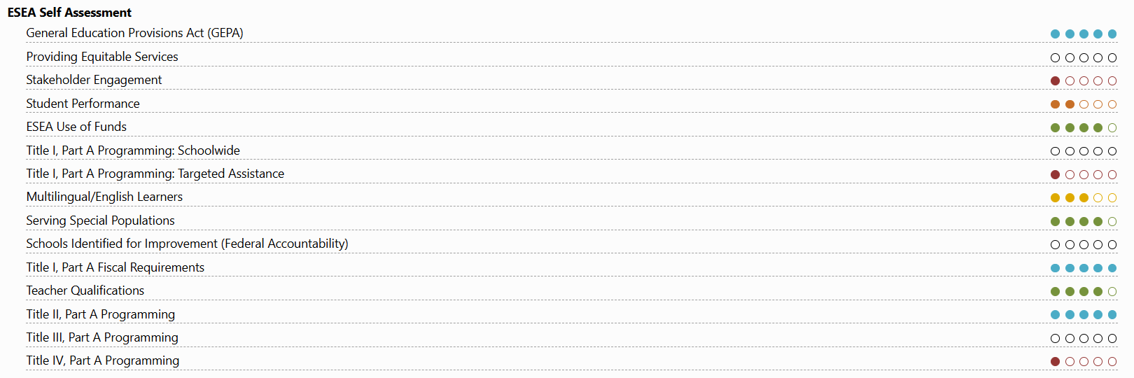 A summary table with the LEA’s ratings is provided on the “LEA: Monitoring Results Response” page. ***Note: A detailed explanation of each of the ratings is provided in the “Program Monitoring Results” overview and in Appendix B.***
4. Below the summary table, additional information is provided for each section of the self-assessment, including one or more of the following components:
   * Rating
     + The LEA will receive an overall rating based on the review of the self-assessment and supporting documentation.
   * Summary
     + A brief description of how the compliance rating was determined after reviewing each program requirement will be provided. The summary may include commendations and recommendations.
   * 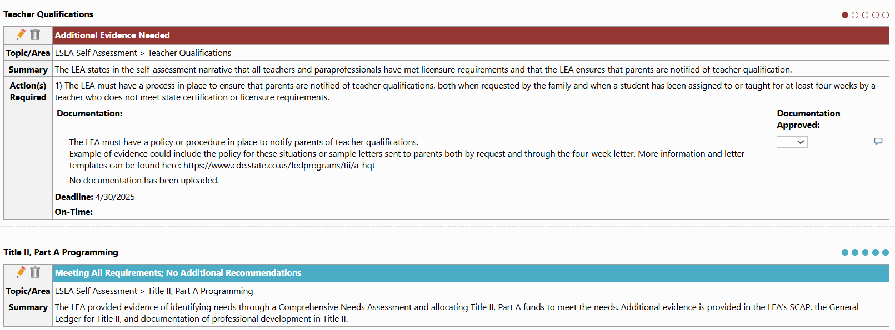Action(s) Required

**Responding to Action(s) Required**

1. 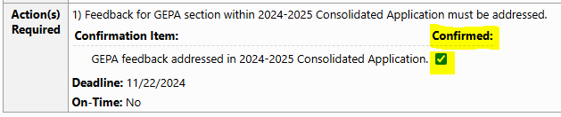If a “Confirmation Item” is the required action, review the information provided and use the checkbox to confirm that the requirement has been met.
2. 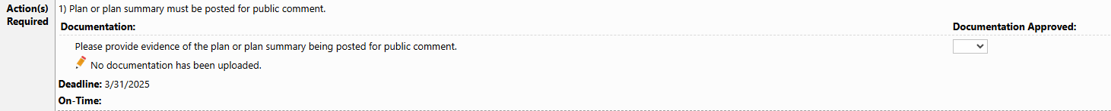If “Documentation” is the required action, click on the pencil icon. Review the information to determine the additional documentation that needs to be submitted.
3. 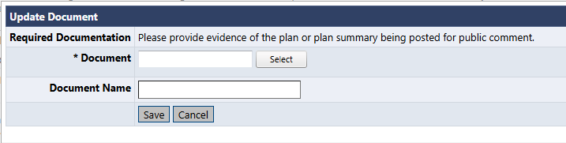A new box will open. Select the document to upload and click “Save.”

## Final Steps

1. The Program Monitoring Office team will continue to monitor the LEA’s progress with addressing any required actions and provide feedback through the “LEA: Monitoring Results Response” page. This process can be repeated multiple times if needed and will continue until all required actions are resolved and approved.

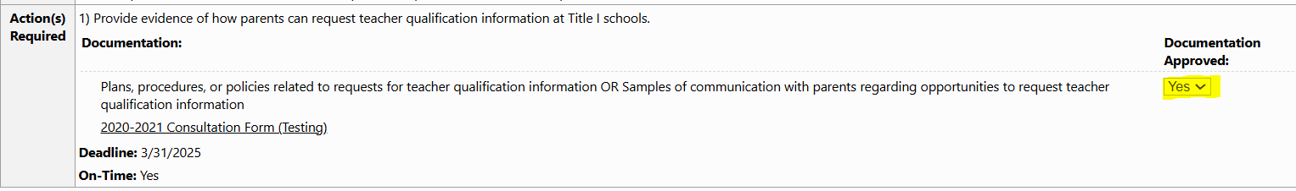

1. When all results have been finalized and the monitoring process is complete, the Status will be changed to “Monitoring Closed.”

# Appendix A: Narrative Response Guidance

### Section 1: General Education Provisions Act (GEPA)

* + **Narrative Response Guidance**: With the LEA’s most recent Consolidated Application GEPA statement(s) in mind, please discuss
    - the LEA’s process for identifying system barriers, mitigation strategies, and desired outcomes (include stakeholder input, progress monitoring/evaluation procedures, and timelines); and
    - the LEA’s implementation of the steps outlined in the GEPA statement.

### Section 2: Providing Equitable Services

* + **Narrative Response Guidance:** please discuss
    - the LEA’s process for providing meaningful consultation with Non-Public Schools (NPS), including examples of timelines for outreach, meeting objectives, agreements between the LEA and NPS, processes for determining ESEA support for NPS, and progress monitoring/evaluation procedures and timelines;
    - the LEA’s process for identifying the number of students living in poverty that attend NPS and live within a Title I boundary for determination of Title I proportionate share, the total enrollment of NPS within district boundaries for determination of funds allocated to equitable services in Titles II and IV, and the number of multilingual learners attending NPS within district boundaries for determination of equitable services in Title III;
    - the LEA’s processes for determining and distributing the proportionate share of federal funds to provide equitable services for students and/or staff at NPS, ensuring activities implemented match the approved budget items, and evaluating the effectiveness of activities; and
    - the LEA’s fiscal plans and procedures for maintaining control of funds and acquired property and tracking any carryover funds.

### Section 3: Stakeholder Engagement

* + **Narrative Response Guidance:** please discuss
    - the LEA’s process and implementation practices for engaging with all stakeholders, including
      * the frequency of stakeholder engagement activities,
      * communication processes,
      * how the LEA develops and revisits LEA and school level parent and family engagement policies,
      * how the LEA incorporates stakeholder feedback in plan development,
      * how the LEA builds the capacity of parents and families to support their students,
      * how the LEA ensures communication with stakeholders in a format and language that parents and families of all participating students can access and understand, and
      * how stakeholder engagement is made an ongoing process throughout the year.

### Section 4: Student Performance

* + **Narrative Response Guidance:** please discuss
    - the LEA’s process for communicating student performance to parents/families, including the LEA’s timelines for communications;
    - the LEA’s process for providing communications in a format and language that parents and families can access and understand; and
    - the LEA’s process for ensuring parents have access to required documents and notifications (Opt-Out, FERPA, PPRA).

### Section 5: ESEA Use of Funds

* + **Narrative Response Guidance:** please discuss
    - the LEA’s process for planning, budgeting, expensing and reporting expenditures for each of the following applicable programs:
      * Title I, Part A;
      * Title I, Part D;
      * Title II, Part A;
      * Title III, Part A;
      * Title III, Immigrant Set-Aside;
      * Title IV, Part A;
      * Title V, Part B.

### Section 6: Title I, Part A Programming: Schoolwide

* + **Narrative Response Guidance:** For LEAs with Title I Schoolwide programs, please discuss
    - the LEA’s process for determining and developing Schoolwide Title I plans, including school-level stakeholder involvement, goal-setting, progress monitoring, timelines, and program evaluation.

### Section 7: Title I, Part A Programming: Targeted Assistance

* + **Narrative Response Guidance**: For LEAs with Title I Targeted Assistance programs, please discuss
    - the LEA’s process for determining and developing Targeted Assistance Title I plans, including school-level stakeholder involvement, goal-setting, progress monitoring, timelines, and program evaluation.

### Section 8: Multilingual/English Learners (MLs/ELs)

* + **Narrative Response Guidance:** please discuss
    - the LEA’s process for meeting with and communicating with parents and families of MLs/ELs regarding the education of their children in attaining English proficiency and meeting Colorado Academic Standards;
    - the LEA’s process for identifying, redesignating, and evaluating MLs; and
    - the LEA’s process for communicating in a format and language that parents and families can access and understand.
    - Include timelines and progress monitoring/evaluation procedures.

### Section 9: Serving Special Populations

* + **Narrative Response Guidance:** Please discuss
    - the LEA’s process for serving special populations, including homeless students, foster care students, early childhood education, and Title I, Part D.
      * For homeless students, include information that supports information in the Consolidated Application, such as how the homeless set-aside funds were spent. Also include information about the LEA’s McKinney-Vento policy, such as a link to the policy, the LEA’s process and timeline for reviewing the policy, and information regarding transportation for homeless children and youth.
      * For foster care students, include information that describes how transportation to the school of origin will be provided and funded, and/or links to written plans, procedures, policies or agreements that include how to make the best interest determination in collaboration with local welfare agencies.
      * For early childhood education, include information that explains the LEA’s coordination with Head Start agencies and other early childhood education providers within the LEA and transition plans and processes between Head Start programs and schools receiving Title I and/or Title III funds.
      * For Title I, Part D, include documentation to support budgeted activities within the Consolidated Application, information regarding the formal agreement between the LEA and facility, documentation of supplemental instructional programs, and documentation supporting that expenditures align with the approved Consolidated Application budget.

### Section 10: Schools Identified for Improvement (Federal Accountability)

* + **Narrative Response Guidance:** please discuss
    - the LEA’s process for notifying schools of their ESSA identification (CS,TS, and ATS);
    - the LEA’s process for supporting, developing and monitoring school improvement plans for ESSA-identified schools; and
    - the LEA’s process for evaluating resource inequities at the district level, and if applicable, how resource inequities are addressed at the CS and ATS schools as required in statute.

### Section 11: Title I, Part A Fiscal Requirements

* + **Narrative Response Guidance:** please discuss
    - the LEA’s Supplement not Supplant methodology and evaluation;
    - the process by which the LEA determines the method of poverty selected;
    - the LEA’s process for the demonstration of compliance with comparability; and
    - the LEA’s processes for ensuring that all ESEA reporting requirements are met.

### Section 12: Teacher Qualifications

* + **Narrative Response Guidance:** please provide
    - a description of the LEA’s process for ensuring teachers serving Title I schools meet requirements and how parents are informed of teachers’ qualifications.
    - If an Equitable Distribution of Teachers gap has been identified for the LEA, describe the strategies implemented to reduce or eliminate the gap.

### Section 13: Title II, Part A Programming

* + **Narrative Response Guidance:** please discuss
    - the LEA’s process for reviewing the comprehensive needs assessment to determine uses of Title II funds for activities to increase teacher and principal quality.

### Section 14: Title III, Part A Programming

* + **Narrative Response Guidance:** please discuss
    - the LEA’s process of providing differentiated assessments for students dually- identified as Special Education and English Learners;
    - the LEA’s process for ensuring that the LEA’s Title III programs are evidence-based and supplemental to core instruction.
    - If applicable, the LEA’s process for determining the needs and supports for immigrant students and families.

### Section 15: Title IV, Part A Programming

* + **Narrative Response Guidance:** please discuss
    - the LEA’s process and implementation practices for prioritizing and distributing Title IV funds to schools in order to increase student achievement, including
      * how funding decisions are made,
      * how the LEA conducts a needs assessment specifically related to Title IV, Part A,
      * how the LEA assesses the effectiveness of Title IV activities, and
      * how the LEA ensures adherence to content category or infrastructure expenditure rules.

# Appendix B: Ratings

|  |  |  |
| --- | --- | --- |
| **Rating** | **Rating Summary** | **Rating Description** |
| 5 blue circles | Meeting All Requirements; No Additional Recommendations | Information provided through the self-assessment, in combination with the additional data and information available to CDE, is sufficient to determine the LEA’s compliance with all requirements. |
| 4 green circles | Meeting All Requirements; Recommendation(s) | When a recommendation is included, a potential area for improvement has been identified. The LEA will not be required to submit additional evidence to demonstrate the completion of the recommendations. |
| 3 yellow circles | Not Meeting All Requirements; Corrective Action(s) | When a corrective action is included, the LEA must respond to any identified corrective actions. The FPSU team will work with the LEA until full compliance is reached. |
| 2 orange circles | Not Meeting All Requirements; Recommendation(s) and Corrective Action(s) | Recommendations and corrective actions may be provided for the same section. The LEA is not required to submit additional evidence to demonstrate the completion of the recommendations. The FPSU team will work with the LEA until full compliance is reached for corrective actions. |
| 1 red circle | Additional Evidence Needed | When information provided through the self-assessment, in combination with the additional data and information available to CDE, is not sufficient to determine the LEA’s compliance with all requirements, the FPSU team will identify additional documentation for submission. Following the review of additional evidence, the LEA’s rating may be updated. If the requested evidence cannot be provided, the FPSU team will work with the LEA to determine next steps. |
| 5 circles with no color | Not Applicable | A rating will not be provided when it is determined that a section is not applicable for the LEA. |