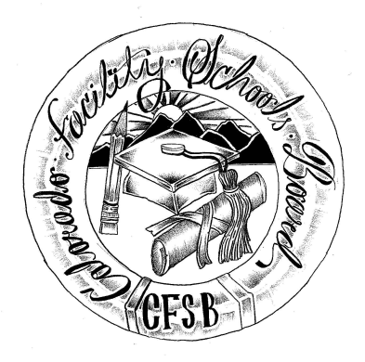
Colorado Facility Schools Board Meeting
Thursday, February 13, 2025
10:00 a.m. – 12:30 p.m.
Venue: Zoom

Time | Agenda Item | Participants
9:45am | Arrivals
10:00am | Board Meeting (Co-Chair calls meeting to order)  Approval of Minutes Action Item  Approval of Agenda Action Item | Board
10:05am | Public Comment –Members of the public who wish to address the board must sign up 24 hours prior to the meeting using this link – Public Comment Sign-up Sheet. Presentations are limited to 3 minutes, with a maximum of 10 people. Additional guidance on public comment on the following page. If you plan to attend a meeting and need translation or accommodations, please notify Lori Kochevar, Kochevar_L@cde.state.co.us, at least 2 weeks prior to the meeting date. Advance notice allows CDE time to set up requested accommodations or translation services before the meeting
10:35am | Responsibility Matrix Mid-Year Review | Virginia Winter/ Mylynda Herrick
10:55am | Confirm Board Vacancies/ April Board Meeting/ Havern Approval Packet | Judy Stirman/ Board
11:00am | February/March Board Page for FS Newsletter/Confirm | Darren Serrato
11:05am | New Accreditation System - Update | Wendy Dunaway
11:25am | Discuss current Day Treatment program requests to Transition to Specialized Day Schools Dialogue Item | Board
11:55am | CDE Team Updates | FS Staff
12:30pm | Adjournment of Meeting  Next Meeting Date – March 13, 2025.  In Person – TACT- 2960 S Umatilla St, Englewood, CO 80110 | Board

Colorado Facility Schools Board Meeting
Thursday, February 13, 2025
10:00 a.m. – 12:30 p.m.

Additional information for those wishing to provide public comment –
This meeting will be open for members of the public for the entire meeting via the zoom link - https://us02web.zoom.us/j/84500956694?pwd=LqCVKZzbrf1fQyhDsYn3WbjWjYqpYT.1

Members of the public who wish to address the board must sign up 24 hours prior to the meeting using this link – Public Comment Sign-up Sheet. Presentations are limited to 3 minutes, with a maximum of 10 people. Additional guidance on public comment below.
Accommodation and Translation Notice:
If you plan to attend a meeting and need translation or accommodations, please notify Lori Kochevar, Kochevar_L@cde.state.co.us, at least 2 weeks prior to the meeting date. Advance notice allows CDE time to set up requested accommodations or translation services before the meeting.
If you have requested accommodations or translation services for a meeting and are then unable to attend, we ask for at least a 72-hour notice of cancellation, so that CDE can be proactive with cancelling requested accommodation services ahead of the meeting. Thank you!
Information regarding public comment:
DO:
§ Introduce yourself and where you are from. If you are speaking on behalf of an organization, identify the organization and your association.
DO: (Continued)
§ If speaking to a specific agenda item, limit your remarks to the subject of the agenda item and avoid repeating what others have said.
§ Be brief, to the point, and concise.
§ If you believe an issue needs to be explained in-depth, and you bring handouts, please pass them to staff prior to making your comments. Be sure to include your name and date of the meeting on the handout.
DO NOT:
§ Expect the board to answer any questions you may have.
§ Expect the board to be able to intervene with local school district issues. As Colorado is a local control state, district-specific issues should be resolved locally.
If you have questions about state law and local requirements, CDE staff may be able to assist you in finding an appropriate way to address your concerns.
§ Discuss personnel matters with the board. This should be done in private with the chair and/or vice-chair of the board.

