These sample RRPs are provided by CDE for convenience only. The State Board retains the right to approve or deny waiver requests as provided in statute, regardless of whether those requests use or do not use CDE’s sample language

SAMPLE: Rationale and Replacement Plan for Waivers from State Statute and Rule

|  |
| --- |
| **Contact Information** |
| **School Name:** East Elementary Charter |
| **School Address (mailing):** 2468 Alpine Drive, Denver, CO 80203 |
| **Charter School Waiver Contact Name:** Bob McDaniels |
| **Charter School Waiver Contact’s Phone Number:** 303-333-3333 |
| **Charter School Waiver Contact’s Email:** [bob.mcdaniels@eastelementarycharter.com](mailto:bob.mcdaniels@eastelementarycharter.com) |
| **District Contact Name:** Lynn Richards |
| **District Contact’s Phone Number:** 720-555-2222 |
| **District Contact’s Email:** [lrichards@Evansk12.co.us](mailto:lrichards@Evansk12.co.us) |

|  |  |
| --- | --- |
| **Automatic Waivers** | |
| **State Statute Citation** | **Description** |
| **C.R.S. § 22-32-109(1)(f)** | **Local board duties concerning selection of staff and pay** |
| **C.R.S. § 22-32-109(1)(t)** | **Determine educational program and prescribe textbooks** |
| **C.R.S. § 22-32-**  **110(1)(h)** | **Local board powers-Terminate employment of personnel** |
| **C.R.S. § 22-32-110(1)(i)** | **Local board duties-Reimburse employees for expenses** |
| **C.R.S. § 22-32-110(1)(j)** | **Local board powers-Procure life, health, or accident insurance** |
| **C.R.S. § 22-32-**  **110(1)(k)(I)** | **Local board powers-Policies relating the in-service training and**  **official conduct** |
| **C.R.S. § 22-32-**  **110(1)(ee)** | **Local board powers-Employ teachers’ aides and other non-**  **certificated personnel** |
| **C.R.S. § 22-32-126** | **Employment and authority of principals** |
| **C.R.S. § 22-33-104(4)** | **Compulsory school attendance-Attendance policies and**  **excused absences** |
| **C.R.S. § 22-63-301** | **Teacher Employment Act-Grounds for dismissal** |
| **C.R.S. § 22-63-302** | **Teacher Employment Act-Procedures for dismissal of teachers** |
| **C.R.S. § 22-63-401** | **Teacher Employment Act-Teachers subject to adopted salary**  **schedule** |
| **C.R.S. § 22-63-402** | **Teacher Employment Act-Certificate required to pay teachers** |
| **C.R.S. § 22-63-403** | **Teacher Employment Act-Describes payment of salaries** |
| **C.R.S. § 22-1-112** | **School Year-National Holidays** |

|  |
| --- |
| **Non-Automatic Waivers: Statute Description and Rationale and Replacement Plan** |
| **C.R.S. § 22-9-106 Local Board of Education-Duties-Performance Evaluation System** |
| **Rationale:** The general design of this statute was written with a focus on practices that apply to BOCES and school districts, but don’t align perfectly to charter models – particularly those that do not use probationary/non-probationary statuses, and employ unlicensed educators. As a result, the waiver seeks to present an approach for the charter school to meet the general  intent of the statute aligned to the operational structures of the more autonomous school model. |
| **Replacement Plan:** The East Elementary Charter Head of School or designee will oversee the evaluation of all personnel. Should any other designated administrator not have Principal Licensure, this should not preclude him or her from administering the evaluations under the direction of the Head of School. The Board of Directors of the school shall oversee the evaluation for the Head of School.  East Elementary Charter will use its own evaluation system as agreed to in the charter contract with Pinetree School District to annually evaluate all educators and any other licensed personnel. East Elementary Charter’s evaluation system will, at a minimum, measure all educator standards outlined in the statute. Staff will be annually trained in this evaluation system. The methods used for the school’s evaluation system will include quality standards that are clear and relevant to the administrators’ and teachers’ roles and responsibilities, be based on research-based practices guiding the science of reading, have the goal of improving student academic growth, and meet or exceed the quality standards established in State Board rule. All applicable staff will receive an annual evaluation that provides ratings that align with the state data collection. Overall ratings will also be based, in part, on measures of student learning, and a percentage that aligns to the current percentage defined in statute. Teacher performance ratings data will be reviewed by the school administration and administrator ratings will be reviewed by the charter board of directors and be used to inform hiring practices and personalized professional development. Leadership from East Elementary shall be encouraged to consult with CDE on the design of the teacher evaluation framework to find opportunities for greater alignment between the local model and state practices. [If school is seeking a reporting  waiver, please include language in this area and include teacher performance rubric or summary of process/framework that is sent as a separate attachment to schools of choice]. |
| **Duration of Waivers:** The waiver will extend for the duration of the contract. |
| **Financial Impact:** The school anticipates that the requested waivers will have no financial impact on the Pinetree School District or the East Elementary Charter budget. |
| **How the Impact of the Waivers Will be Evaluated:** Since teacher performance has a critical impact on the performance of the entire school, the impact of this waiver will be measured by the same performance criteria and assessments that apply to the school, as set forth in the charter contract. The Board of Directors of the school and school leader will annually evaluate  the effectiveness of their evaluation system and make adjusts as they may deem appropriate. |
| **Expected Outcome:** If granted, the waiver will enable the school to implement its program and evaluate its teachers in accordance with its Performance Appraisal System, which is  designed to produce greater accountability and be consistent with the school’s goals and objectives. This will benefit staff members as well as students and the community. |

|  |
| --- |
| **Non-Automatic Waivers: Statute Description and Rationale and Replacement Plan** |
| **C.R.S. § 22-32-109(1)(n)(I) Board of Education-Specific Duties School Calendar**  **C.R.S. § 22-32-109(1)(n)(II)(B) Board of Education-Specific Duties Adoption of District Calendar**  **C.R.S. § 22-32-109(1)(n)(II)(A) Board of Education – Teacher Pupil Contact Hours** |
| **Rationale:** East Elementary Charter will prescribe the actual details of its own school calendar to best meet the needs of its students. As such, the school will have a calendar that may differ  from the rest of the schools within Pinetree School District. East Elementary Charter will always meet at least the minimum required time and days as outlined in state law. |

|  |
| --- |
| **Replacement Plan:** The final calendar and the school’s daily schedule will be designed and approved by the East Elementary Charter’s Board of Directors and will meet or exceed the requirements in state statute. The Board will adopt a policy that specifies a process regarding how and when a calendar is adopted and how changes to the calendar are made. A copy of the calendar will be distributed to parents of East Elementary Charter. To the extent possible, East Elementary Charter will endeavor to develop a calendar that aligns with the calendar of  Pinetree School District. |
| **Duration of Waivers:** The waiver will extend for the duration of the contract. |
| **Financial Impact:** The school anticipates that the requested waivers will have no financial impact on the Pinetree School District or the East Elementary Charter budget. |
| **How the Impact of the Waivers Will be Evaluated:** The impact of this waiver will be measured  by the same performance criteria and assessments that apply to the school, as set forth in the charter contract. |
| **Expected Outcome:** As a result of this waiver, the school will be able to operate in accordance with its own schedule, designed to meet the needs of its community and educational program, which is vital to the success of its program. |

|  |
| --- |
| **Non-Automatic Waivers: Statute Description and Rationale and Replacement Plan** |
| **C.R.S. § 22-32-109(1)(b) Local Board Duties Concerning Competitive Bidding**  **C.R.S. § 22-32-110(1)(y) Local Board Powers-Accepting Gifts, Donations, and Grants** |
| **Rationale:** In order to manage its own budget and finances, East Elementary Charter must be granted the authority to develop its own financial policies and practices. East Elementary Charter, rather than Pinetree School District, is in the best position to know what goods and  services are needed and which vendors and providers may be available. |
| **Replacement Plan:** East Elementary Charter Board of Directors will adopt a policy concerning competitive bidding, as required by applicable law, and for selecting successful bidders on projects/contracts. East Elementary Charter will ensure the process is open, transparent, and  in compliance with all applicable rules and regulations. Additionally, the board will adopt a policy for accepting gifts, grants and donations. |
| **Duration of Waivers:** The waiver will extend for the duration of the contract. |
| **Financial Impact:** The school anticipates that the requested waivers will have no financial impact on the Pinetree School District or the East Elementary Charter budget. |
| **How the Impact of the Waivers Will be Evaluated:** The impact of this waiver will be measured by the same performance criteria and assessments that apply to the school, as set forth in the  charter contract. |
| **Expected Outcome:** East Elementary Charter expects that, because of this waiver, it will be  able to manage its own financial affairs. |

|  |
| --- |
| **Non-Automatic Waivers: Statute Description and Rationale and Replacement Plan** |
| **C.R.S. § 22-63-201 Employment Certificate Required** |
| **Rationale:** East Elementary Charter must be granted the authority to hire teachers and principals that will support the school’s goals and objectives. The principal will not function as a traditional District school principal, but rather will be responsible for a wider range of tasks and act as the school’s chief executive officer. East Elementary Charter will seek to attract principals and teachers from a wide variety of backgrounds, including, but not limited to teachers from out-of-state, teachers with a lapsed Colorado certificate, persons with several years of successful teaching experience in a setting not requiring a license, as well as persons  with business or professional experience. |

|  |
| --- |
| **Replacement Plan:** All East Elementary Charter employees will meet the guidelines set forth in the Colorado state ESSA plan, specifically (1) endorsement on a Colorado teaching license;  (2) holding at least a BA or higher in the relevant subject area; (3) completing 36 semester credit hours in the subject matter in which s/he teaches; or (4) passing a State Board approved content exam in the relevant subject area. All school employees will meet applicable fingerprinting and background check requirements. Special Education Teachers will hold the requisite state license and endorsement. East Elementary Charter will report the number of in- field/out-of-field teacher designations, years of experience of teachers, or any other requirements promulgated by CDE. |
| **Duration of Waivers:** The waiver will extend for the duration of the contract. |
| **Financial Impact:** The school anticipates that the requested waivers will have no financial  impact on the Pinetree School District or the East Elementary Charter budget. |
| **How the Impact of the Waivers Will be Evaluated:** The impact of this waiver will be measured  by the same performance criteria and assessments that apply to the school, as set forth in the Charter Agreement. |
| **Expected Outcome:** As a result of this waiver, East Elementary Charter will be able to operate  in accordance with its own program and hire teachers that best fit the school’s design, which is vital to the success of its program. |

|  |
| --- |
| **Non-Automatic Waivers: Statute Description and Rationale and Replacement Plan** |
| **C.R.S. § 22-63-202 Teacher Employment, Contracts in Writing-Duration-Damage Provision**  **C.R.S. § 22-63-203 Probationary Teachers-Renewal and Non-renewal of Employment Contract** |
| **Rationale:** To manage its own personnel, East Elementary Charter must be granted the authority to select its own teaching staff, develop its own employment agreements and terms and conditions of employment. |
| **Replacement Plan:** All East Elementary Charter employees will be employed on an at-will basis. East Elementary Charter has written teacher agreements with the terms of non-renewal and renewal of employment agreements, and payment of salaries upon termination of employment of a teacher. As a result of these waivers, the school will be able to employ professional staff possessing unique skills and/or background, filling all staff needs. |
| **Duration of Waivers:** The waiver will extend for the duration of the contract. |
| **Financial Impact:** The school anticipates that the requested waivers will have no financial  impact on the Pinetree School District or the East Elementary Charter budget. |
| **How the Impact of the Waivers Will be Evaluated:** The impact of this waiver will be  measured by the same performance criteria and assessments that apply to the school, as set forth in the Charter Agreement. |
| **Expected Outcome:** East Elementary Charter expects that, as a result of this waiver, it will be able to manage its own personnel affairs. |

|  |
| --- |
| **Non-Automatic Waivers: Statute Description and Rationale and Replacement Plan** |
| **C.R.S. § 22-63-206 Transfer of Teachers** |
| **Rationale:** East Elementary Charter has a unique curriculum for which having the proper teaching staff is essential. No other school nor Pinetree School District should have the authority to transfer its teachers into or from East Elementary Charter. |

|  |
| --- |
| **Replacement Plan:** East Elementary Charter will not participate in the district’s transfer policies and procedures; however, to the extent that teachers are transferred to other positions or grades within the school, there shall be no discrimination shown toward any teacher in the assignment or transfer of that teacher because of sex, sexual orientation, marital status, race, creed, color, religion, national origin, ancestry, or membership or non-membership in any group or organization. Race includes hair texture, hair type, or a protective hairstyle that is commonly or historically associated with race. |
| **Duration of Waivers:** The waiver will extend for the duration of the contract. |
| **Financial Impact:** The school anticipates that the requested waivers will have no financial  impact on the Pinetree School District or the East Elementary Charter budget. |
| **How the Impact of the Waivers Will be Evaluated:** The impact of this waiver will be  measured by the same performance criteria and assessments that apply to East Elementary Charter, as set forth in the Charter Agreement. |
| **Expected Outcome:** East Elementary Charter expects that, as a result of this waiver, it will be able to manage its own personnel affairs. |

|  |
| --- |
| **Non-Automatic Waivers: Statute Description and Rationale and Replacement Plan** |
| **C.R.S § 22-7-1014(2)(a) Preschool Individualized Readiness Plans – School Readiness – Assessments** |
| **Rationale:** East Elementary Charter is a data driven school that is constantly evaluating and  assessing students’ academic readiness, character development, and physical well-being in order to ensure student success. East Elementary Charter already has strong programs and assessments in place that assess students’ school readiness relating to physical well-being, social-emotional development, language and comprehension development, cognition, and  general knowledge (literacy and mathematics). |
| **Replacement Plan:** Every kindergarten student at East Elementary Charter will be administered a school readiness assessment within the first 60 calendar days of the school year. The assessment instruments used will be research based, reliable and valid. East Elementary Charter intends on using the below assessment instrument(s) to assess each of the domains outlined in the statute:  Physical well-being & motor: {Insert assessment name} Social and Emotional: {Insert assessment name} Language & Comprehension: {Insert assessment name} Cognition: {Insert assessment name}  Math: {Insert assessment name} Literacy: {Insert assessment name}  The data collected from these assessment(s) will be used to develop an individualized readiness plan for each kindergarten student and will inform individual learning plans, RtI, and drive classroom instruction within the school. This school readiness data will not be used to deny admission or progress to first grade. The data collected will be made readily available to Pinetree School District, and East Elementary Charter will report this data, as required by  State law. |
| **Duration of Waivers:** The duration of the contract. |
| **Financial Impact:** The school anticipates that the requested waivers will have no financial impact on Pinetree School District or the East Elementary Charter budget. |
| **How the Impact of the Waivers Will be Evaluated:** The impact of this waiver will be measured by the performance criteria and assessments that apply to East Elementary Charter. |
| **Expected Outcome:** As a result of this waivers, East Elementary Charter will be able to  implement the necessary policies to increase student achievement within existing structures. |

NOTE: This statute requires each school to administer a school readiness assessment to every Kindergarten student within 60 days from the start of the school year. Waiver from this only waives the school from having to use one of the state board approved school readiness assessments. Schools with this waiver still must administer a kindergarten readiness assessment that assess all domains (physical well-being, social-emotional development, language and comprehension development, cognition, general knowledge – math, and general knowledge – literacy).

The statute is looking for the **assessment** tool being used, not the instructional classroom practices.

***Please list the assessment tool on the plan.***

If your school is using one of the listed assessment instruments lists below, then a waiver for 22-7- 1014(2)(a) is not necessary.

* **HighScope Educational Research Foundation**, COR for Kindergarten
* **Desired Results Developmental Profile for Kindergarten (DRDP-K),** WestEd
* **North Carolina Kindergarten Entry Assessment**
* **Teaching Strategies**, GOLD
* **Dial-4 Developmental Profile- Kindergarten,** NCS Pearson, Inc. (coupled with Aims Webb Plus Early Literacy)

If your school is not using one of these, please indicate how your school intends to meet the 6 domains. Please refer to the chart below for guidance. Green boxes under domain indicate that the assessment tool is acceptable.

For additional information please visit [Assessment Choices and School Readiness Plans](https://www.cde.state.co.us/schoolreadiness/assessment)

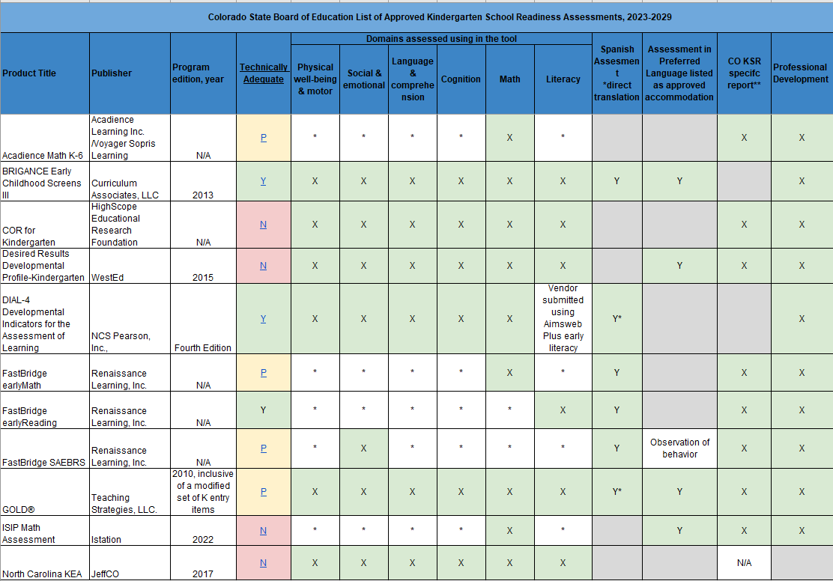

For additional information please visit [Assessment Choices and School Readiness Plans](https://www.cde.state.co.us/schoolreadiness/assessment)