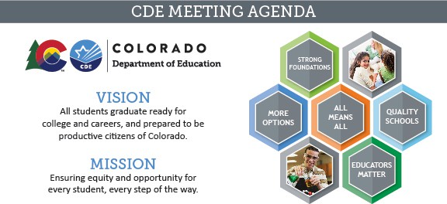

Meeting Logistics & Desired Outcomes

Meeting: ESSA Committee of Practitioners Date & Time: Thursday, August 13th at 9:00 am Location: Virtual: Zoom

Meeting Leads: Laura Gorman (Chair), Tammy Giessinger (CDE Lead), and Jeremy Meredith (CDE Lead)

Objectives: To allow the Colorado Department of Education the opportunity to provide updates to and elicit recommendations from the Colorado Committee of Practitioners regarding relevant and timely issues related to CDE’s responsibilities under the Elementary and Secondary Education Act (ESSA).

**Attendees:** Joshua Shoemaker, Chaille Hymes, Mitzi Swiatkowski, Arlene Salyards, Michelle Barkemeyer, Erich Dorn, Moses Regidor, Amy Beruan, Christy Sinner, Laura Gorman, Heathre Palige, Clare Vickland, John McKay, Holly Goodwin

Agenda Items and Next Steps

|  |  |  |
| --- | --- | --- |
| **Headline Time**  **Presenters** | **Agenda Item Prep** | **Summary/Notes** |
| **Committee Business 9:00-9:15**  *Laura Gorman, Mark Kirkemier* | Review and Approve the May 7 Meeting Minutes.  Introductions by Mark Kirkemier | The May 7th Meeting Minutes are approved. |
| **Membership 9:15-9:45**  *Tammy Giessinger & Jeremy Meredith* | Welcome to Erich Dorn & Christy Sinner!  Co-Chair Nomination | Joshua Shoemaker was voted in as co-chair. |



|  |  |  |
| --- | --- | --- |
| **Headline Time Presenters** | **Agenda Item Prep** | **Summary/Notes** |
| **Purpose & Vision for the Future of CoP 9:45-10:00**  *Mark Kirkemier, Nazanin Mohajeri- Nelson, and Laura Gorman* | To discuss the purpose of CoP and the vision for working collaboratively and in partnership to brainstorm and problem- solve issues and concerns with implementation of ESSA during the COVID-19 pandemic.” | Presentation Highlights:   * We want a partnership where both CDE staff and CoP members are bringing topics to the meeting for problem-solving and discussion. * Reflect on prior years on what has worked and what has not. How can we re-evaluate our priorities for this upcoming year?   Feedback from CoP Members on the Agenda Topics for 2020-2021:   * Sometimes it is difficult to provide feedback on prospective changes before the work begins. |
| **Agenda Topics for 2020-21**  **10:00-10:30**  *Tammy Giessinger & Jeremy Meredith* | Receive input from CoP members on agenda topics for the 2020-2021 school year. | Feedback from CoP Members on the Agenda Topics for 2020-2021:   * Members could review the bylaws independently and provide input prior to the September meeting. * When we look at supporting students with IEPs we might want to break this up into breakout sessions regarding students on IEPs, ELs and Mental health support. * Add CDE fiscal to our CoP meetings.   *CDE will take this back to Jennifer Austin in Grants Fiscal to request that they attend  future CoP meetings. |



|  |  |  |
| --- | --- | --- |
| **Headline Time Presenters** | **Agenda Item Prep** | **Summary/Notes** |
|  |  | * NPS have not heard from LEAs about CARES Act funds. * The supporting students with IEPs may not fall under our committee’s purpose. (This could be an ESEA Office Hours topic). * Remove the ELP Growth/On-Track Reports and wrap into Accountability updates if that ties in. * Provide a small update on Monitoring for ESEA and ESSER in the September agenda. * Is monitoring a priority during this time? * System upgrades are platform upgrades to fix any glitches in the 2020-2021 Consolidated Application. This should be moved to the November meeting. * CoP members recommend that CDE create and disseminate a simple survey to help CoP members with these Cons App discussions. * Add Title IV Reporting Requirements to the September agenda. * Add waiver requests (CDE requesting from the USDE) to the carryover fund discussion in the November meeting.   Next Steps: Connect with Laura or Josh if you  have other agenda topic ideas. |



|  |  |  |
| --- | --- | --- |
| **Headline Time Presenters** | **Agenda Item Prep** | **Summary/Notes** |
| **EDT: Request to Reconsider 10:30-11:00**  *Jeremy Meredith & Tina Negley* | Collecting/discussing feedback on “Process and Guidance” document, particularly regarding next steps if gaps remain after R2R completed.  **Prep:** Read over the Process and Guidance document | Feedback from CoP Members:   * Teacher coverage will be difficult. * If a teacher is isolated, we may need to hire new teachers. * CDE survey to collect feedback from the field.   Next meeting: September 24th |